**Restaurant Billing System**

**Name:** Malapati Naresh Reddy

**Table of Content:**

* Introduction
* SWOT Analysis
* Strength
* Weakness
* Opportunities
* Threats
* 5W’s and 1H
* Features of the project
* High Level and Low Level Requirements
* Flowcharts
* Output Images
* Conclusion

**Introduction**

Restaurant Billing System is a computer based billing system with user friendly interface which automatically manages the billing process of the customer very easily taking only a short period of time .I have included 2 section one for Manager and other for customer.

Each section contains 5 modules. The customer has options like ordering food, list of items in the restaurant, Final bill. On the other hand the manager (Admin) has options like number of items sold, add/delete items in menu, display order menu.

**SWOT Analysis**

* **Strengths**

1) To reduce workload to staff

2) To reduce the delay in processing time.

3) To reduce the delay in bill generation.

4) To provide greater flexibility.

5) Make maintenance changes easy.

* **Weakness:**

Late payments occurs when the internet connection is slow.

* **Opportunities:**

It can be used in restaurants for ordering food, billing.

It provides the list of items in the restaurant with prices so that the customer can easily order the items accordingly

* **Threats:**

Can be easily replicated

* **5'W, 1H**

1. **what:** Restaurant Billing System
2. **Where:** In Restaurants
3. **why:** To take orders from customers and generate Bills
4. **who:** Restaurant management
5. **When:** first step is to give order after that we can give the bill to the customer
6. **How:** Works based on users Inputs

* **Features:**

1) Display Order Menu

2) Place an order

3) Add/delete items in order list

4) Generating bill

5) Showing the list of items in restaurant

6) View total sales items

* **High Level Requirements :**

1. Admin Section
2. Customer Section
3. Exit

* **Low Level Requirements:**

1. Display List of Items
2. Add items in menu
3. Delete items in menu
4. View your ordered items
5. View Total Sales
6. Place your order
7. Display Bill with amount
8. Back to main menu

* **Flowcharts:**

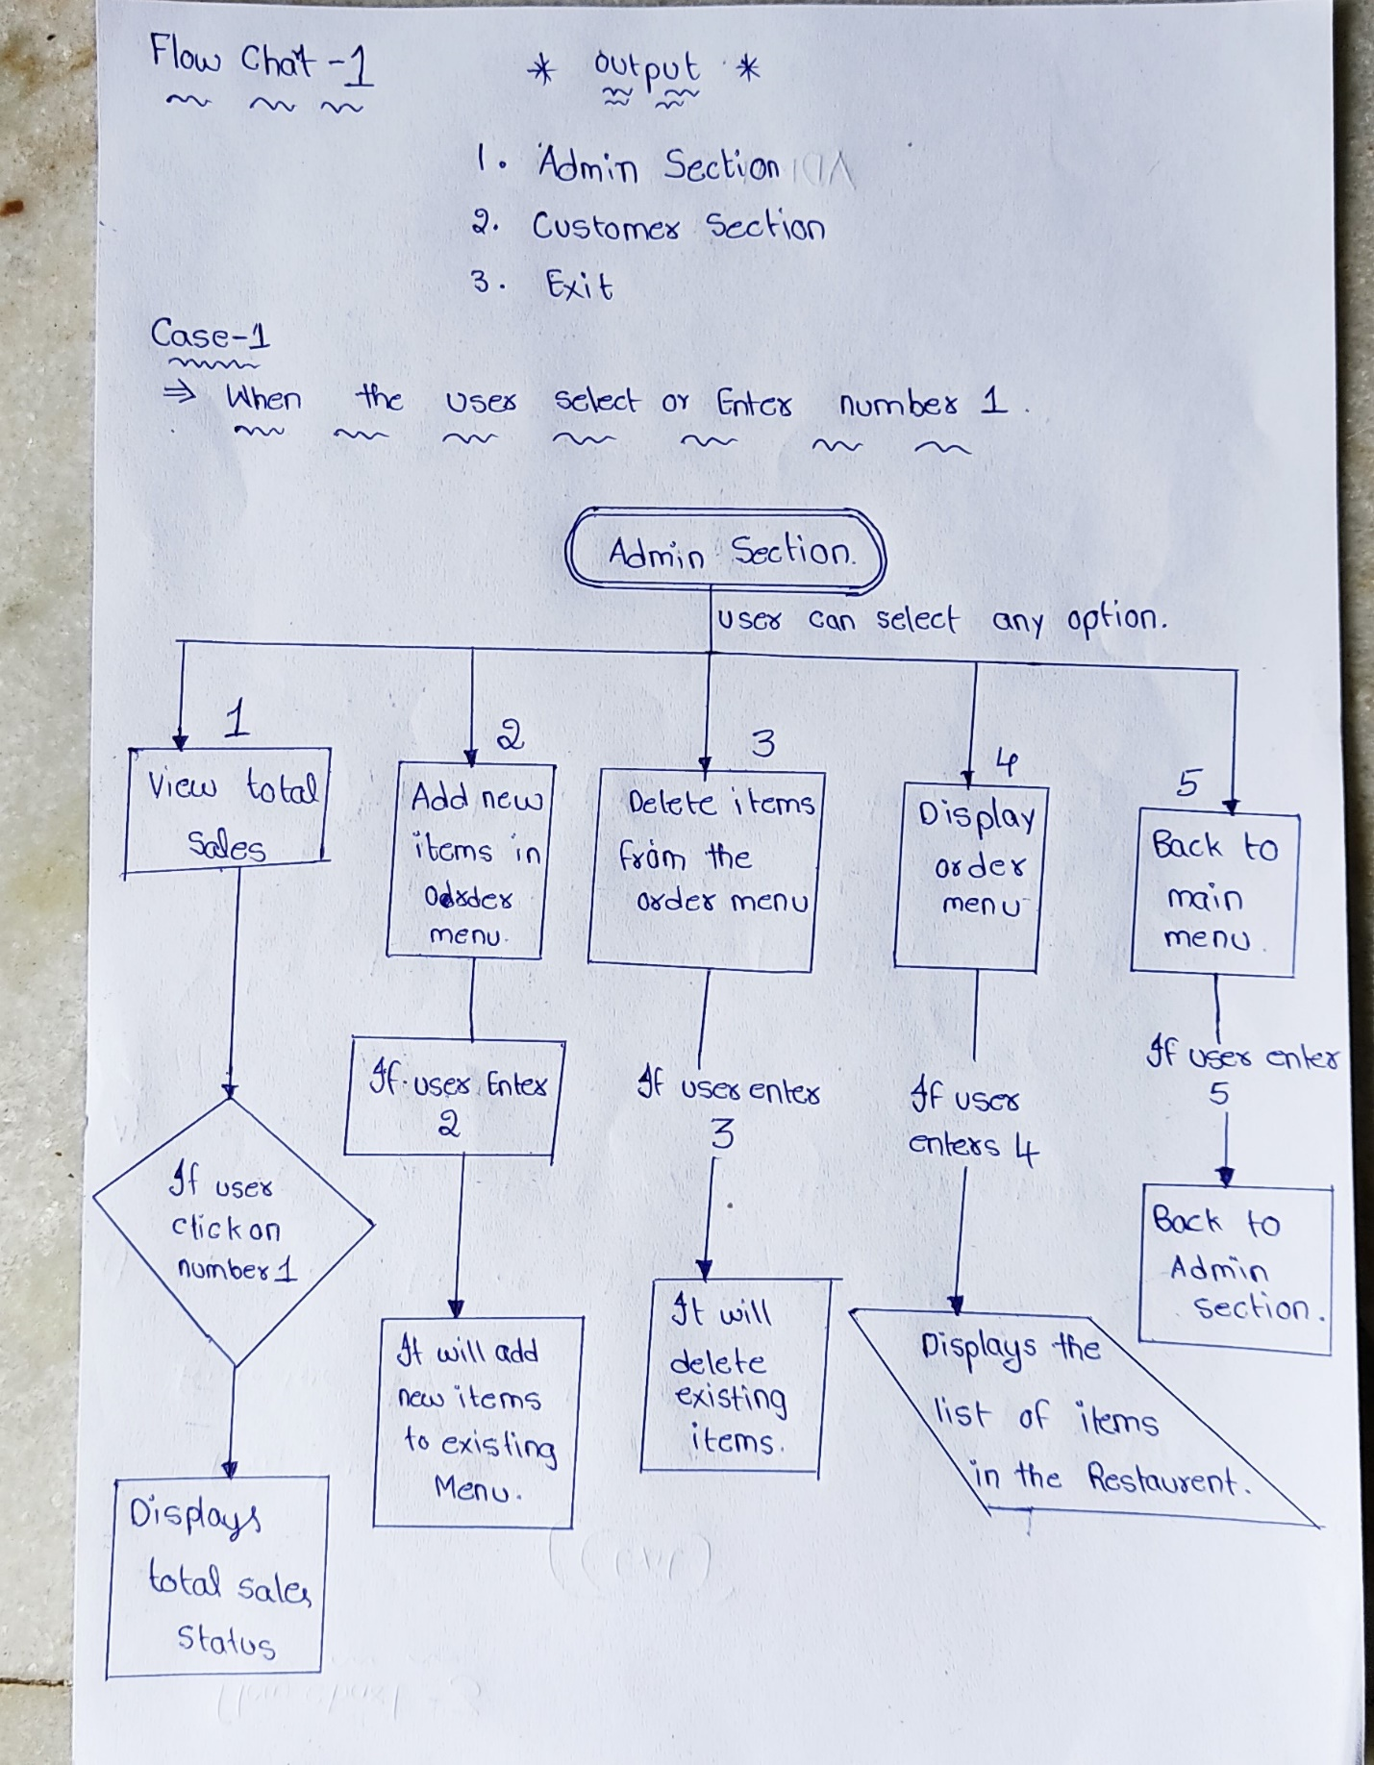

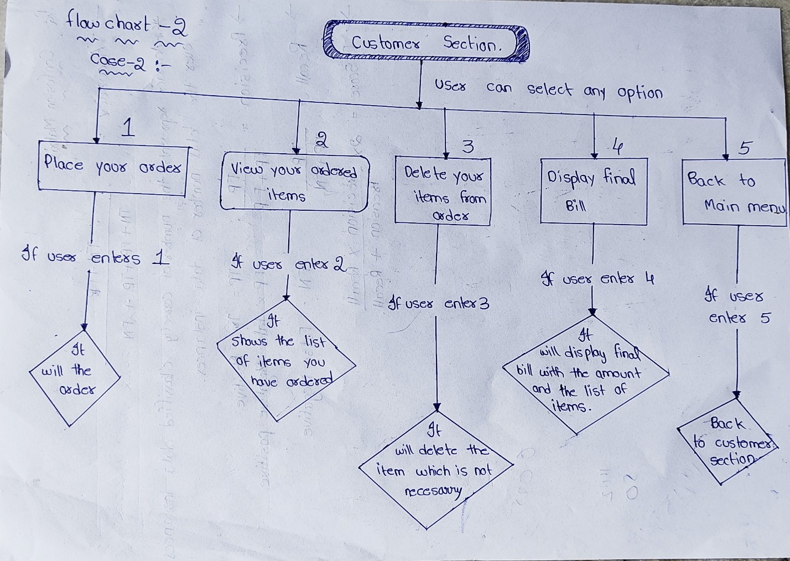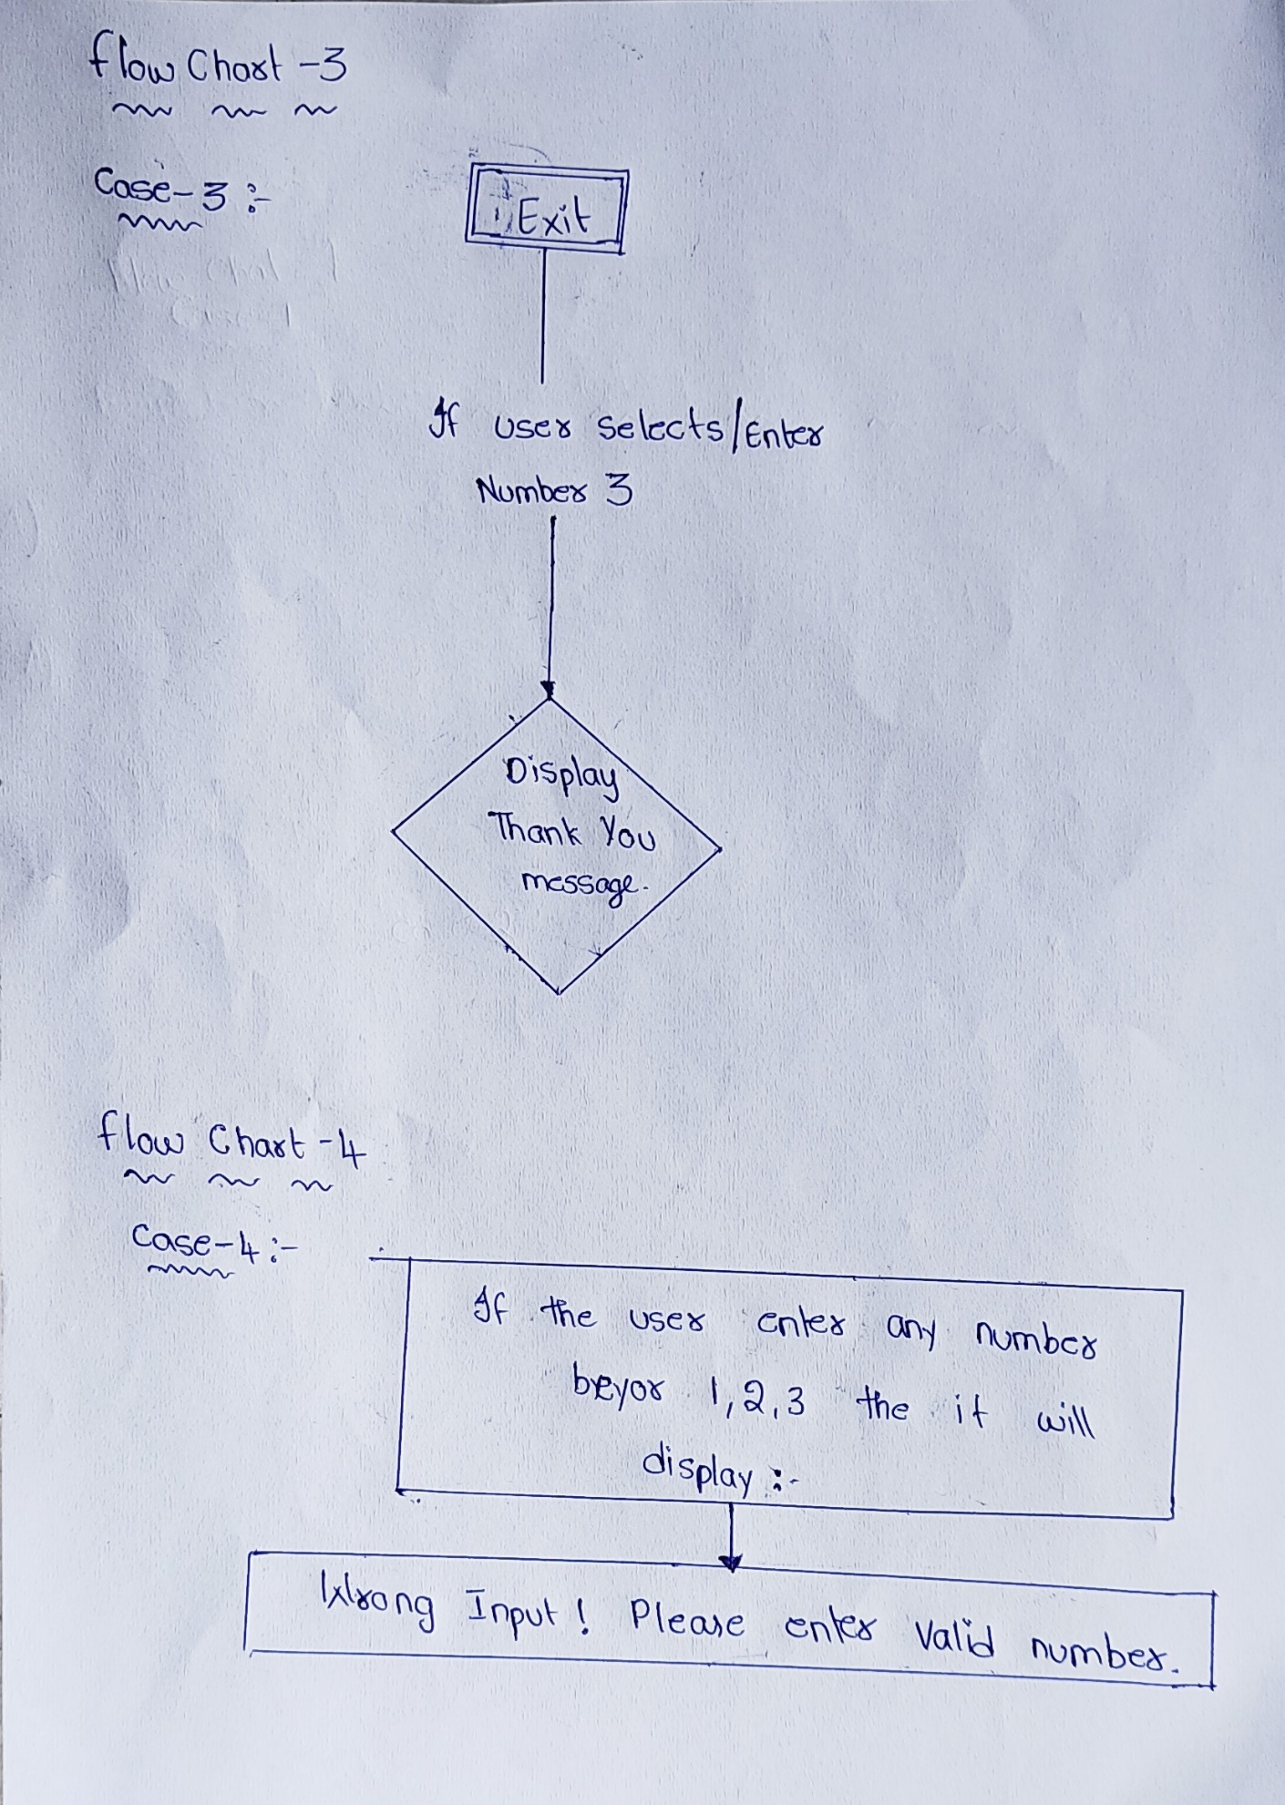

* **Output Images:**

**case-1**

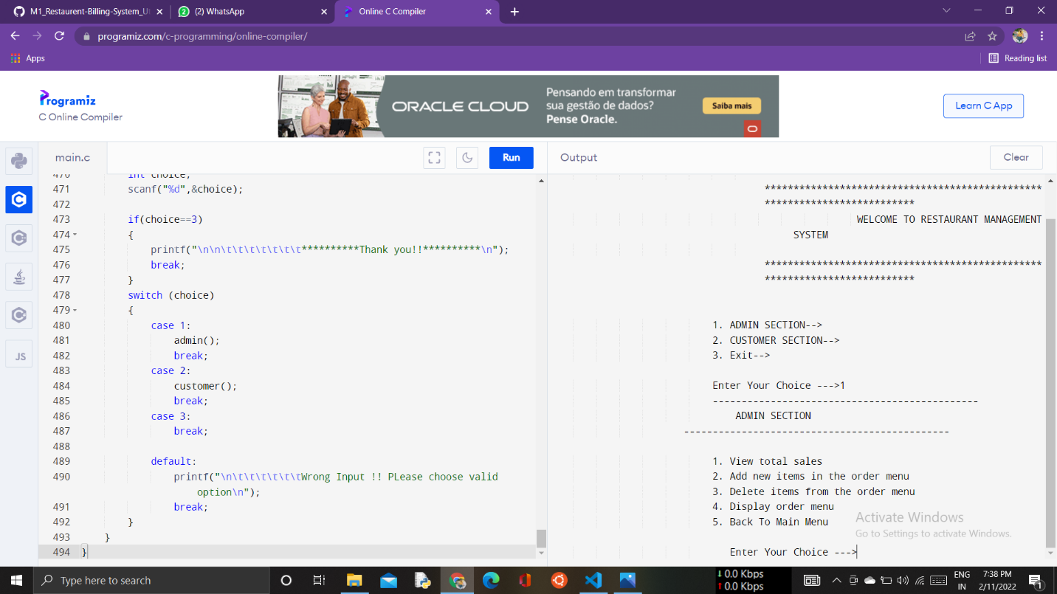

**Case-2:**

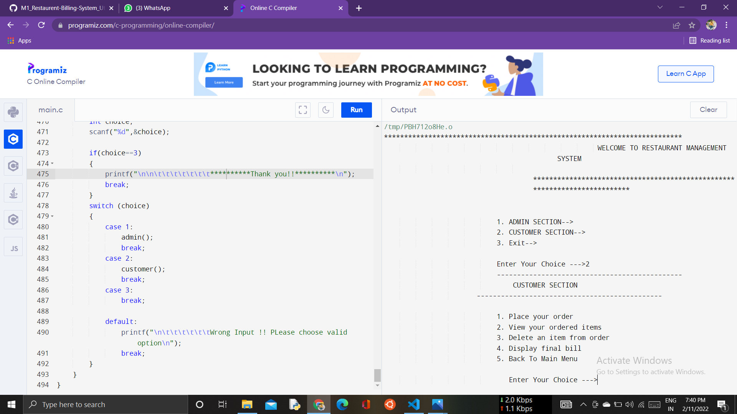

**Case-3:**

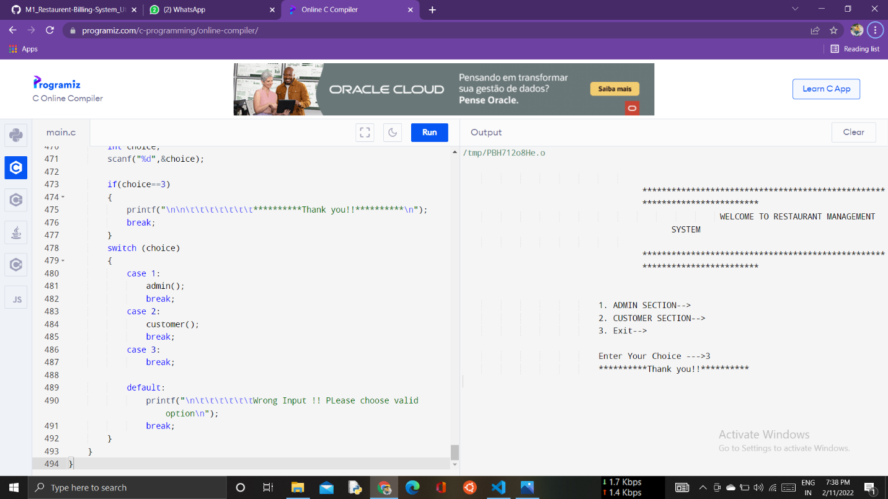

**Case-4:**

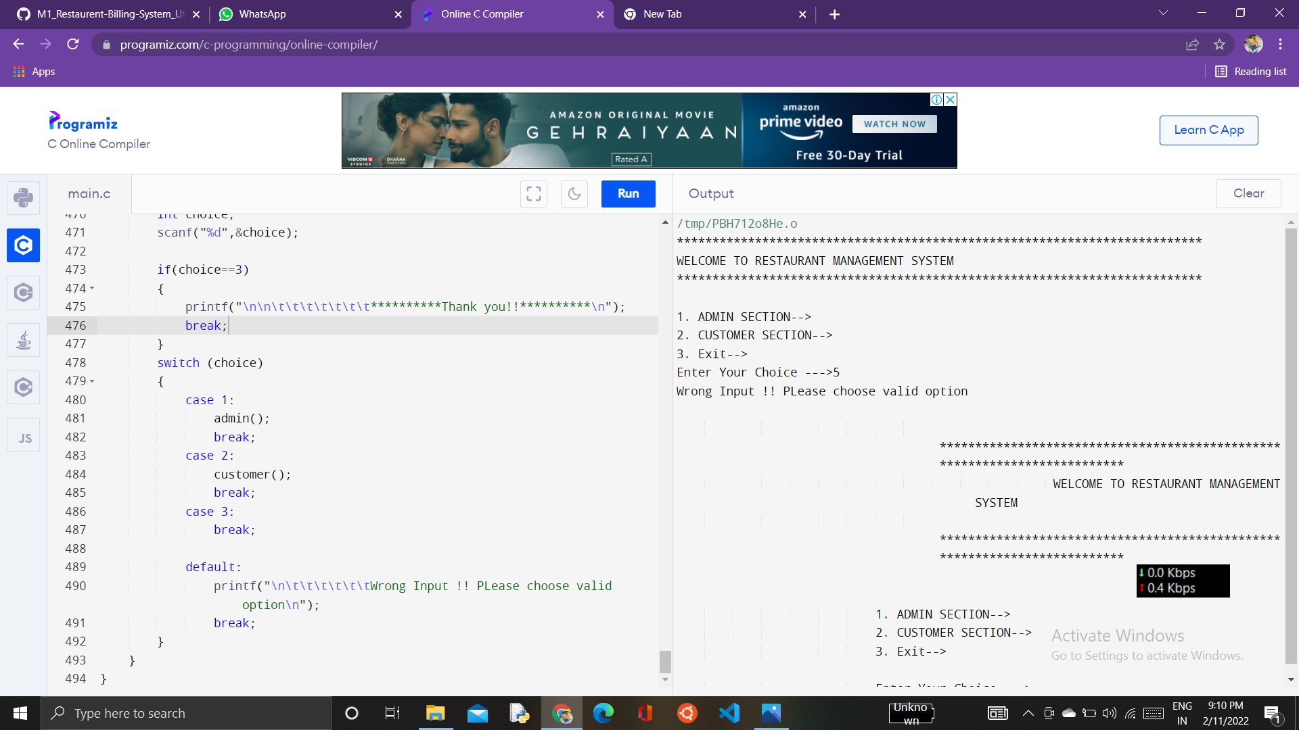

* **Conclusion**

I have planned system which takes the necessary choices of the customer according to the various filter like price, category of the food. Then he is able to place the order accordingly and then the system calculates all the total of the order and then it can dispatch the bill that is handed over to the customer.